Project Design Phase-II
Data Flow Diagram & User Stories

Date | 15 June 2026
Team ID | Pulkit Khera
Project Name | OnlineComplaintRegistration
Maximum Marks | 4 Marks

Data Flow Diagrams:
A Data Flow Diagram (DFD) is a traditional visual representation of the information flows within a system. A neat and clear DFD can depict the right amount of the system requirement graphically. It shows how data enters and leaves the system, what changes the information, and where data is stored.
Example: (Simplified)
User Stories
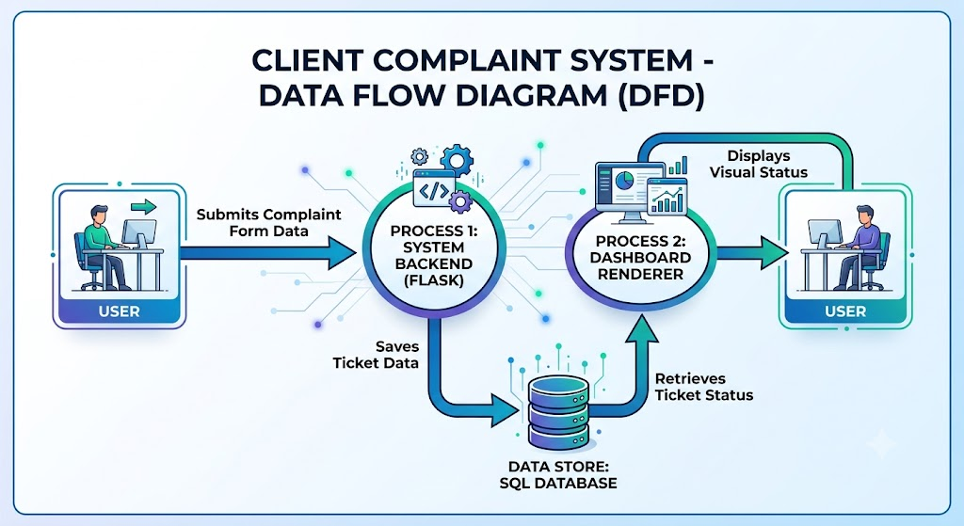
Use the below template to list all the user stories for the product:
User Type | Functional Requirement (Epic) | User Story Number | User Story / Task | Acceptance criteria | Priority | Release
Customer (Web user) | Registration & Login | USN-1 | As a web user, I can register and log in to the portal securely. | I can access my personalized dashboard upon successful login. | High | Sprint-1
Customer (Web user) | Complaint Submission | USN-2 | As a web user, I can submit a grievance with a title, category, and description. | A unique Ticket ID is generated and saved to the database. | High | Sprint-2
Customer (Web user) | Status Tracking | USN-3 | As a web user, I can view a list of my submitted complaints and their current status. | Dashboard displays accurate statuses (Pending, Resolved) from the database. | High | Sprint-2
Administrator | Ticket Management | USN-4 | As an admin, I can view all submitted complaints across the system. | Admin dashboard loads a table of all user tickets. | Medium | Sprint-3
Administrator | Status Update | USN-5 | As an admin, I can update the status of a specific complaint to "Resolved". | The database updates, and the user sees the new status. | Medium | Sprint-3
User Type | Functional Requirement (Epic) | User Story Number | User Story / Task | Acceptance criteria | Priority | Release
Customer (Web user) | Registration & Login | USN-1 | As a web user, I can register and log in to the portal securely. | I can access my personalized dashboard upon successful login. | High | Sprint-1
Customer (Web user) | Complaint Submission | USN-2 | As a web user, I can submit a grievance with a title, category, and description. | A unique Ticket ID is generated and saved to the database. | High | Sprint-2
Customer (Web user) | Status Tracking | USN-3 | As a web user, I can view a list of my submitted complaints and their current status. | Dashboard displays accurate statuses (Pending, Resolved) from the database. | High | Sprint-2
Administrator | Ticket Management | USN-4 | As an admin, I can view all submitted complaints across the system. | Admin dashboard loads a table of all user tickets. | Medium | Sprint-3
Administrator | Status Update | USN-5 | As an admin, I can update the status of a specific complaint to "Resolved". | The database updates, and the user sees the new status. | Medium | Sprint-3

